**Knowledge and Theory: C and C++**

**Part 1 – C++ Sample Code**

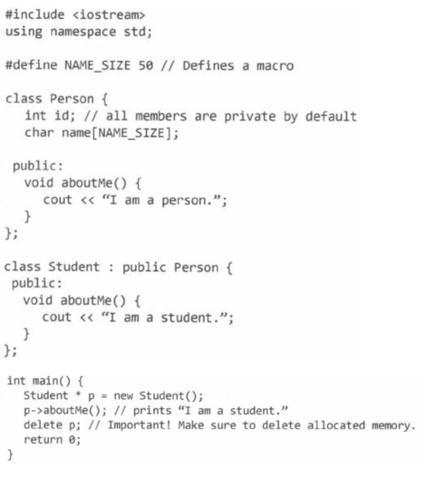

**Things to Notice**

* The include and using namespace
* The constant definition for “name size” with the hashtag
* The method declarations and the access modifier (public)
* The print statement
* The way inheritance is implied with “class Child : public Parent{ }”
* The signature for main. The fact that it is of type integer and that you return zero at the end of it.
* The asterisk with object initialization
* The array instead of the dot operator for method invocations
* The fact that you have to delete allocated memory for the object initializations
* Note: C++ access modifiers are private by default

**Part two – Differences between C ++ and Java**

* In C++, there are constructors and there are deconstructors. A deconstructor is a method that gets executed when the object “dies”. This happens when the object gets out of scope (i.e. the object was a local variable and your about to return from it or the object was in main and your about to return from main) or the object ges deleted explicitly. They are initialized with a tilda (~) symbol.

